Guide to Obtaining Informed Consent
  - A PD-Net Study Design Brief
Consent to participate in a research study should be understood as a process rather than an event [1]. Researchers should plan for and articulate the steps by which consent is initially obtained and the steps by which it is reviewed throughout the study. In order for participants to give meaningful consent, they should be able to understand the intent of the research, be clear about what they are being asked to do and if any risks are involved, and know how their information will be used.

Enabling Informed Consent
Consent may be documented in many ways. Oral or implied consent are as legitimate as written consent, and in some contexts may even be more appropriate. The key idea is to go over the information verbally and document the process of gaining consent in field notes so as to leave a written trail. Even with oral consent, however, is still reasonable to leave written material with the participant (e.g., an information letter).
Consent must always be in language that is understandable and not legalistic or too scientific, and the consent process should make room for questions, as appropriate to the research context. When a written-and-signed approach to consent is used, the information letter and consent form are best presented as one document.
The Information Letter should begin with an invitation to potential participants and should explain why they have been asked to participate. The body should provide a brief (i.e., a paragraph or two), plain-language description of the PD-Net project (examples in English can be found in Appendix B), the particular study that participation is sought for, and the nature of participation. An explanation of how key ethics issues—such as consent and confidentiality—will be handled, along with a discussion of risks and benefits, and compensation if any, should follow. The information letter should be written as if it was being sent from the researcher to the participant, that is, in the 2nd person. It should include an introduction of the researchers and their affiliations.
The Consent Form should include a brief summary of what will happen from the participant’s perspective—without redundancy. It should note that the study has been explained to the participant, and the participant has had a chance to have his or her questions answered. The basic elements of consent, bulleted below, should be taken into account relevant regardless of process – whether written in hard copy, via e-mail, on the web, or presented verbally in person or over the phone. However, not all items are appropriate for all protocols, and some additional items may be useful on a case by case basis. Appendix A contains an example form.

General Points
- Use letterhead of the department/organization undertaking the research
- The language level is appropriate to the age and reading level of the participant population
- Affiliation and contact information for the investigators and (where appropriate) research coordinator is included
- Participants are given a copy of the information letter to keep for their own

Introductory Remarks
- Introductory information on PD-Net
- An invitation to participate should be worded in a professional and respectful manner
- The time commitment and the location of where the study will be conducted should be clarified.
- The reason why the potential participant is being approached should be explained, and a list of relevant inclusion and exclusion criteria, should be provided.
- If relevant, the number of participants who will be involved should be mentioned (e.g., if this could affect confidentiality - see below)

Conditions for participating
- There must be an explicit statement that the individual’s participation is voluntary, and that he/she may refuse to participate, may withdraw at any time, and may decline to answer any question or participate in any parts of the tasks – all without negative consequences
- Any conditions on withdrawal of data if the participant chooses to withdraw from the study should be clarified (e.g., if data are anonymized or de-linked, they cannot be withdrawn; similarly, it is almost impossible to withdraw data from a focus group discussion)
- Information regarding use of audio and video recordings (including potential use for presentation purposes) should be broken out as separate options, to which participants can consent (or not).

Risks/Benefits
- Reasonably foreseeable risks, harms or inconveniences, and how they will be managed should be clearly explained in lay terms
- Potential benefits—including information that there is no direct benefit—should be mentioned, as appropriate
- Information about any payment or compensation for participation or expense reimbursement should be mentioned (but not over-emphasized)

Access to information, confidentiality, and publication of results
- Information regarding who will have access to the data should be clarified, including sharing data among PD-Net partners
- Information regarding retention and disposition (e.g., deletion) of the data during and after completion of research is relevant. Note: destruction of data is not the only acceptable method of disposition. Methods will depend on the identifiability, sensitivity, and richness of the data.
- If applicable, different degrees of confidentiality should be presented as options
- The procedures for maintaining confidentiality should be described, if relevant—e.g., use of study-specific ID numbers, pseudonyms, generic descriptors, composites, or aggregates
- Any foreseeable limits to confidentiality—e.g., for participation in focus groups, research involving key informants or duty to report—should be mentioned
- The researcher’s intent to publish or make public presentations based on the research should be made explicit
- A summary of the research results, and a mechanism to provide the summary, should be offered
See also the definition of Informed Consent given in the Directive 2001/20/EC [2] relating to the implementation of good clinical practice in the conduct of clinical trials on medicinal products for human, which also applies to other (i.e., non-clinical) EU-funded research. See also Directive 95/46/EC [3] for general guidelines regarding the role of informed consent.

Bibliography
- Informed Consent Guide, University of Toronto, Research Ethics Board (REB), April 2010
- Directive 2001/20/EC of the European Parliament and of the Council of 4 April 2001 on the approximation of the laws, regulations and administrative provisions of the Member States relating to the implementation of good clinical practice in the conduct of clinical trials on medicinal products for human use.OJ L 121, 1.5.2001.
- Directive 95/46/EC of the European Parliament and of the Council of 24 October 1995 on the protection of individuals with regard to the processing of personal data and on the free movement of such data OJ 23 November 1995 No L. 281 pp. 0031-0050.

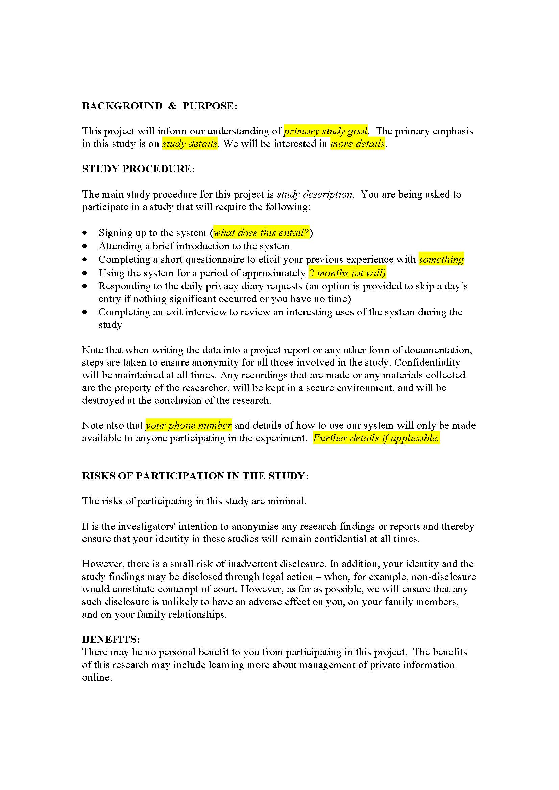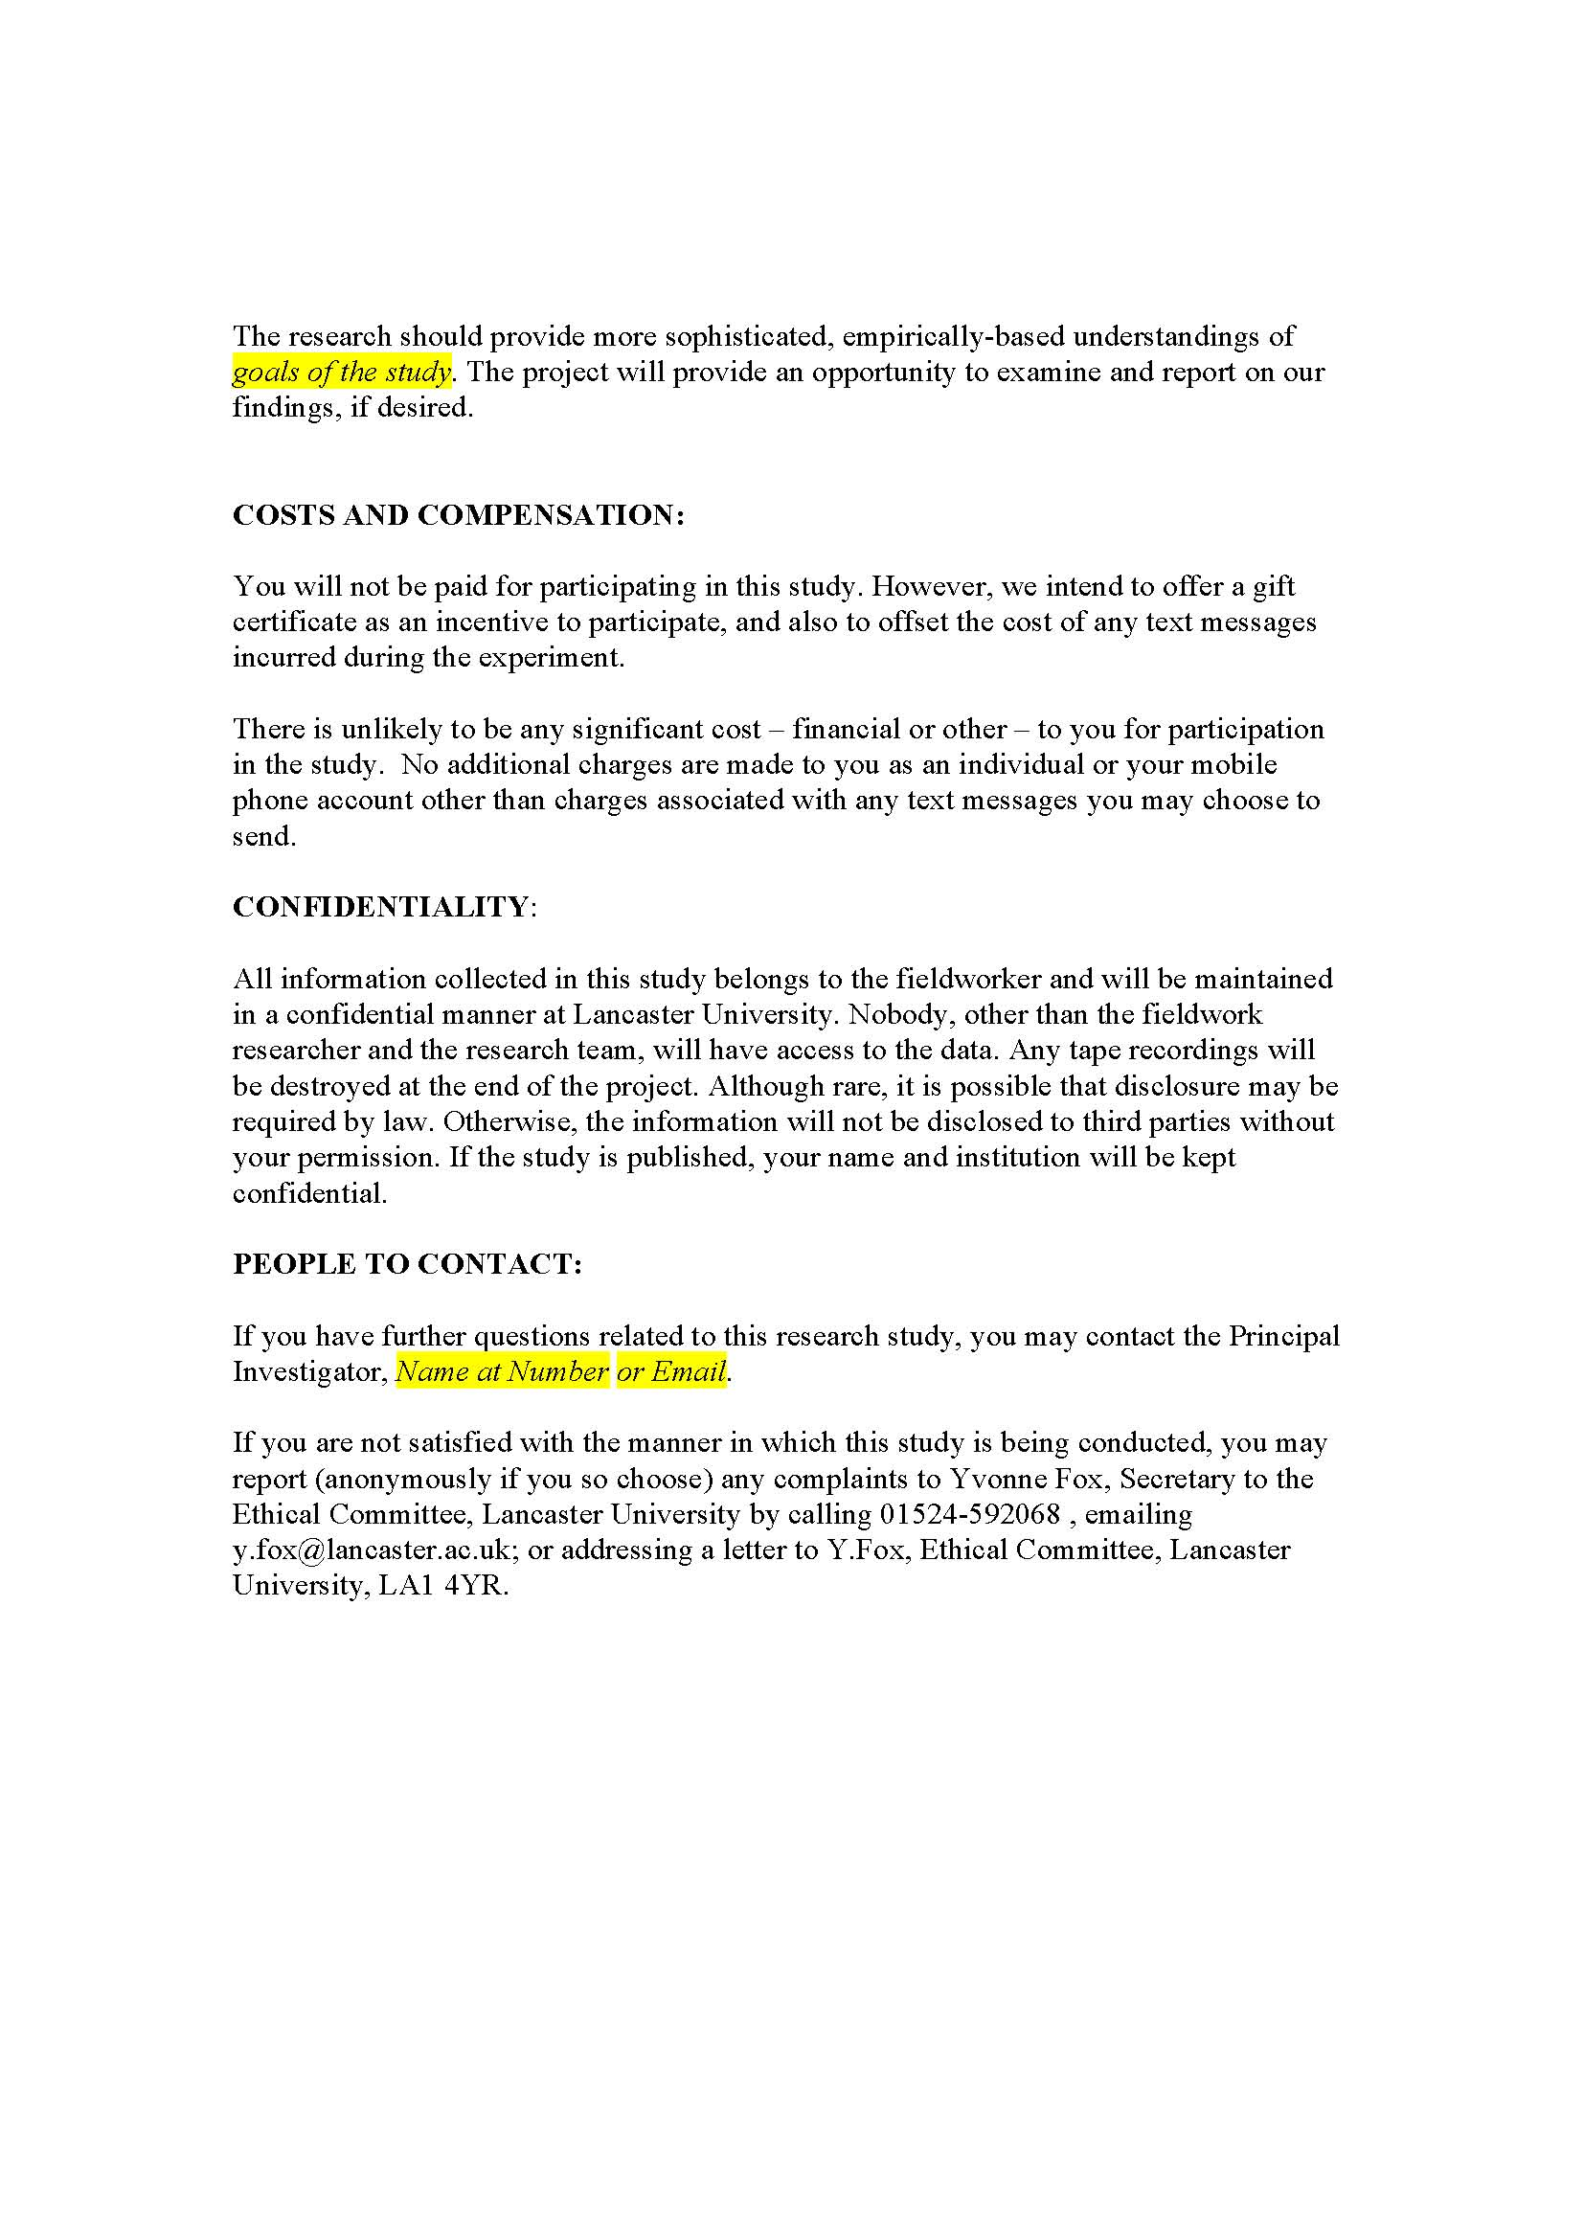
Appendix A:
Example of Informed Consent Form (Lancaster University)
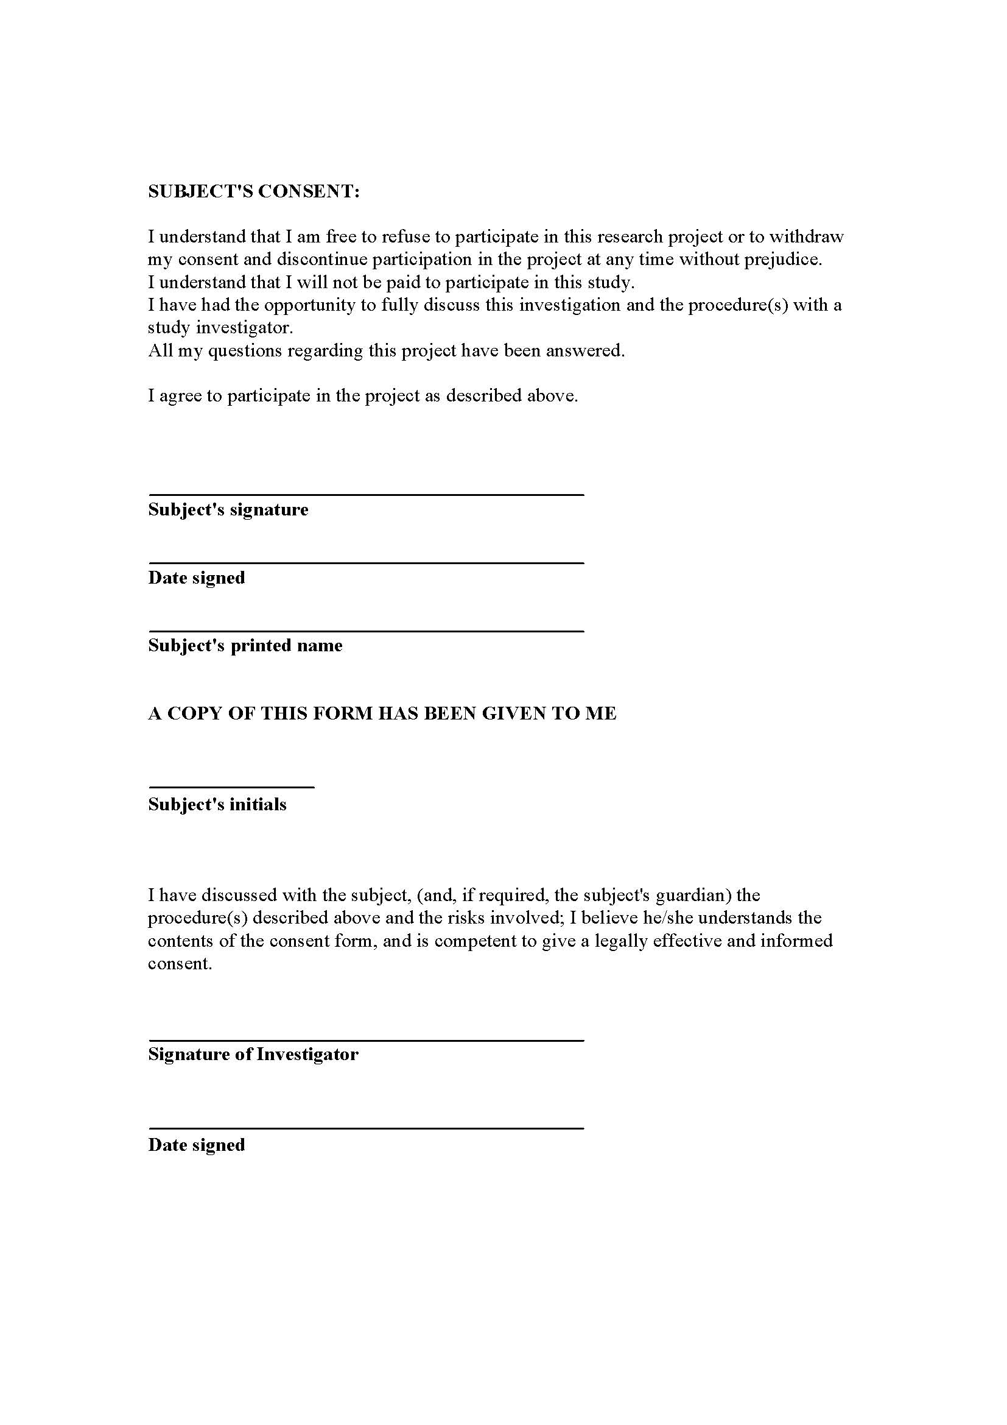
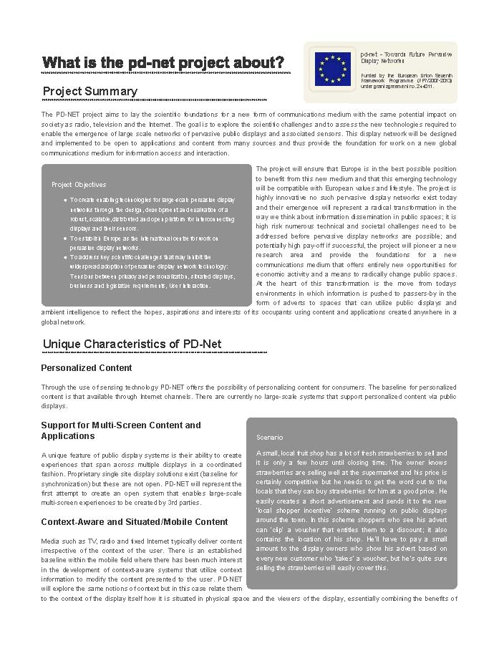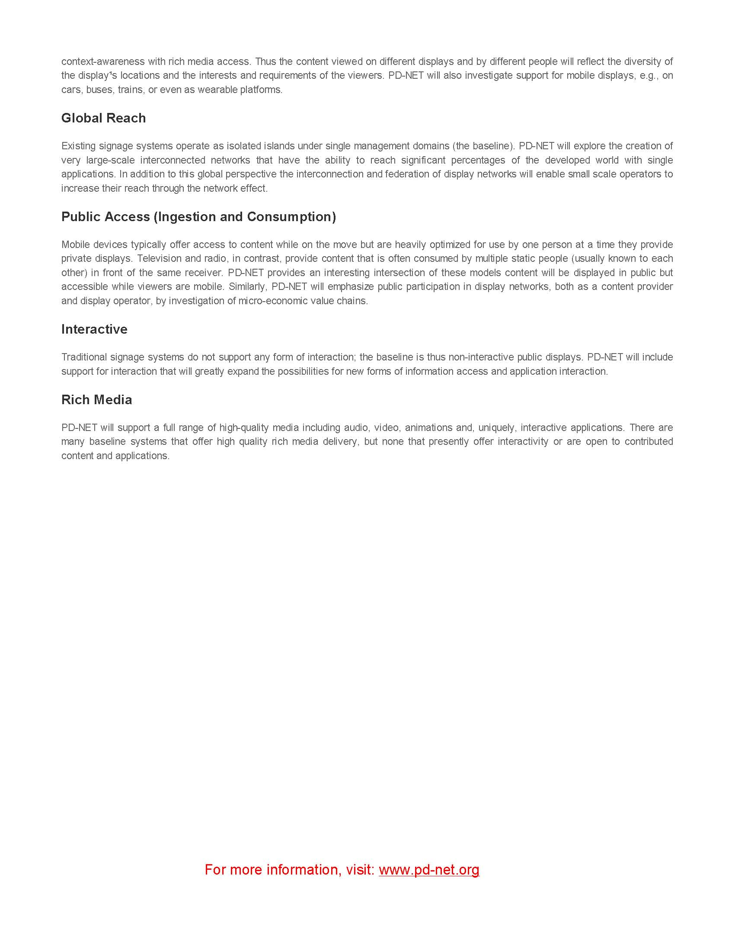
Appendix B: PD-Net Project Description Handout
(available as separate file, about-pdnet.pdf)
Appendix B: Project Description Handout
(available as separate document, about-pdnet.pdf)

